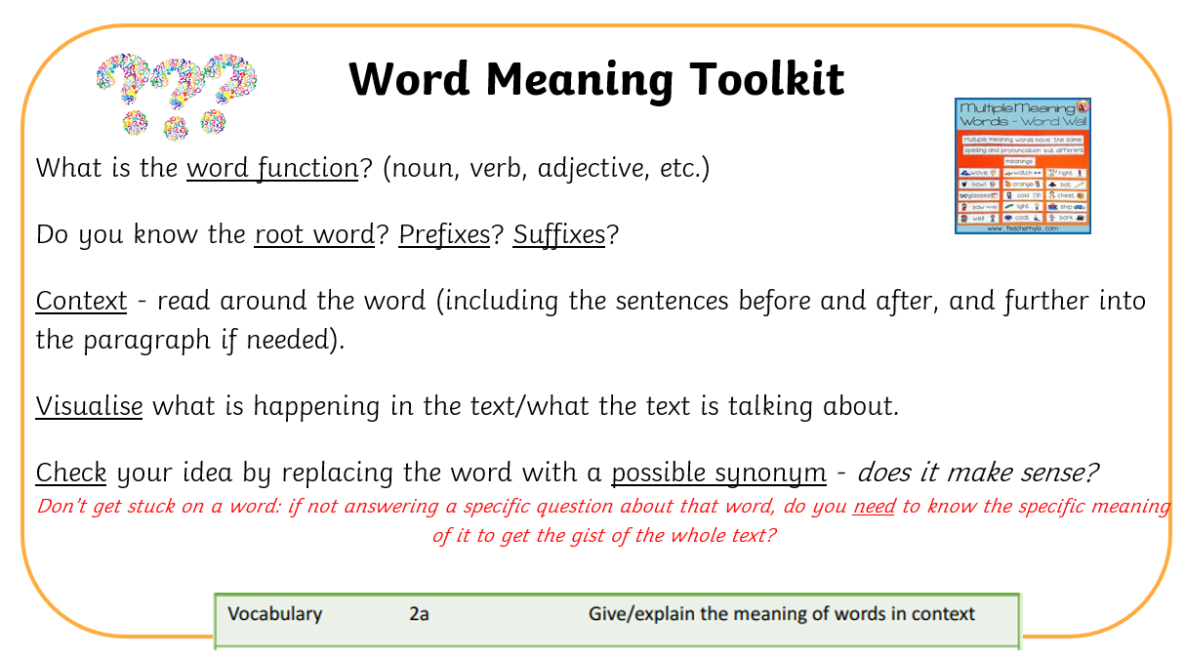 | What do you think ___ means in this sentence?  Which word could replace ___ without changing the meaning?  Does ___ mean the same as ___ here? Why or why not?  How do the words around ___ help you work out its meaning?  Why do you think the author chose the word ___?  Can you explain how you know what ___ means?  Which part of the sentence helped you understand ___?  Can you use ___ in a sentence of your own?
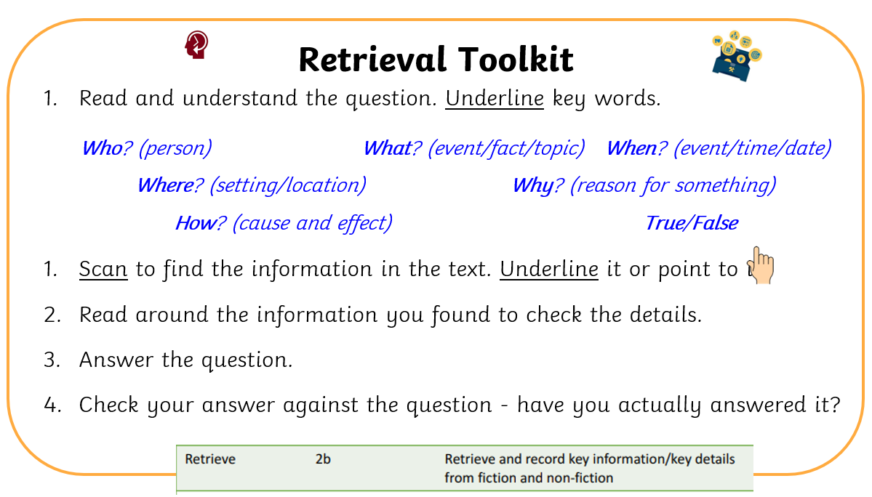 | Can you find the part of the text where it says…?  Which sentence tells you…?  Where in the text does it say…?  Which word/phrase shows…?  What does the text say about…?  Who/what/where/when…?  According to the text, …  Can you copy the words that tell you…?
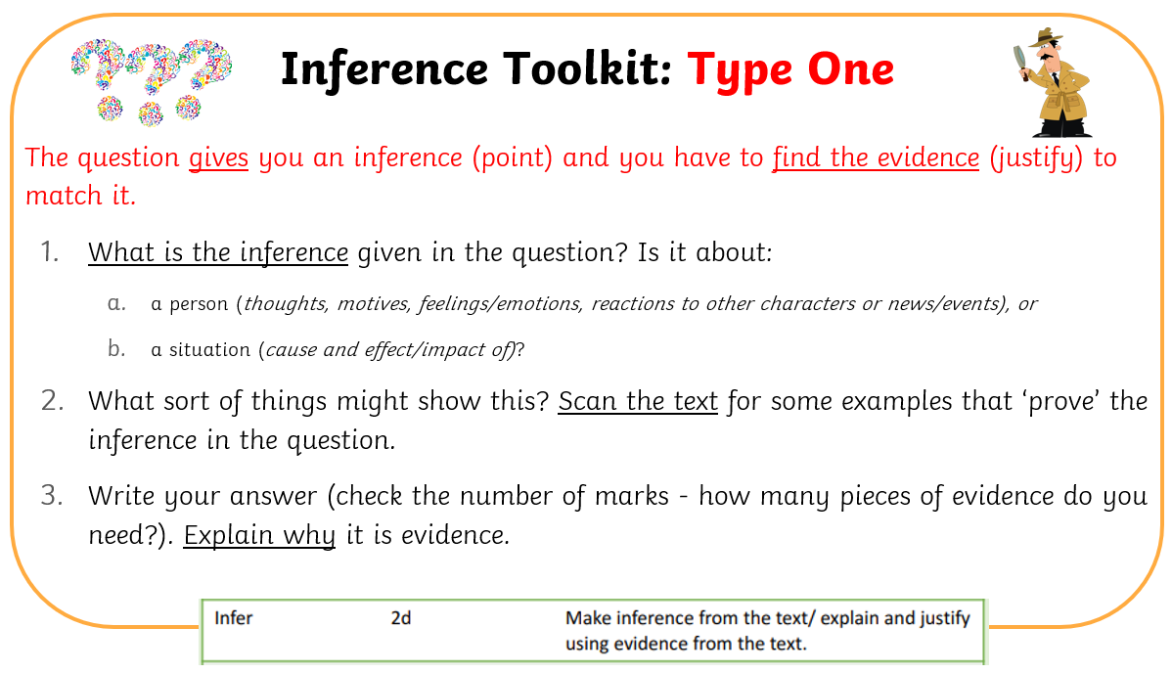 | How do you know that ___? (feeling sad, happy, angry, confused)  What clues in the text tell you this?  Why do you think the author included this information?  Which words or actions of the character support this idea?  Why are they feeling….? (sad, happy, angry, confused)
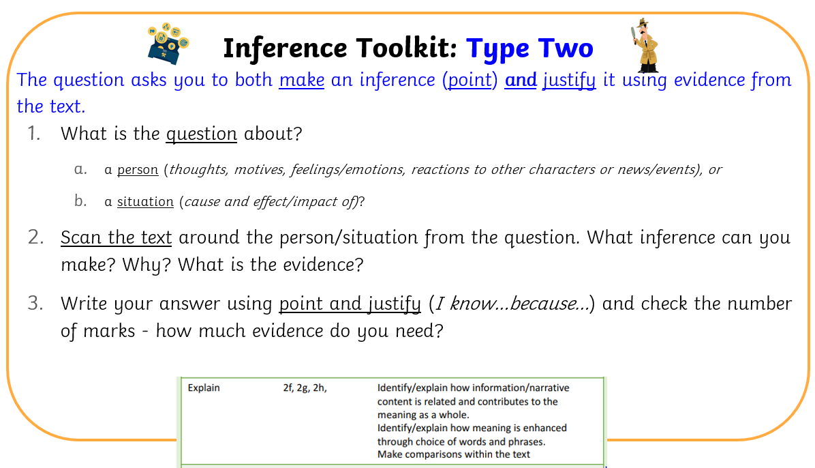 | What do you think is happening here, even though it isn’t said directly?  What can you tell about ___ from what is written?  How is ___ feeling? How do you know?  What does this sentence tell you about the character/situation?  What impression do you get of….?  What is their character like?
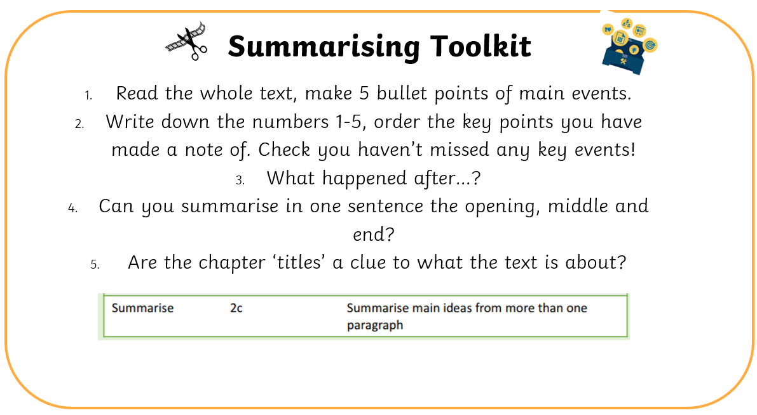 | What is the most important part of this paragraph/chapter?  Which events/details are the most important to remember?  If you had to tell someone the main idea of this section, what would you say?  What happened first, next, and last?  Are there any details that are not important for the summary?  Could you make the summary shorter and still include the main ideas?  Does anything in the text change the main idea? How?
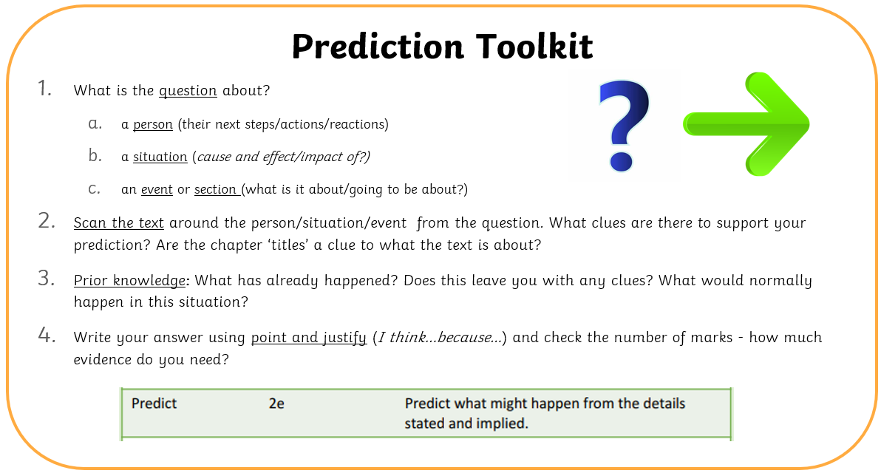 | What do you think will happen next?  Based on what has happened so far, what might happen in the next chapter or paragraph?  How do you think ___ will react to ___?  What do you expect to happen to ___? Why?  Which words or actions in the text give clues about what might happen?  What events so far make you think ___ will happen?  Can you point to a sentence that hints at the next event? Why?

