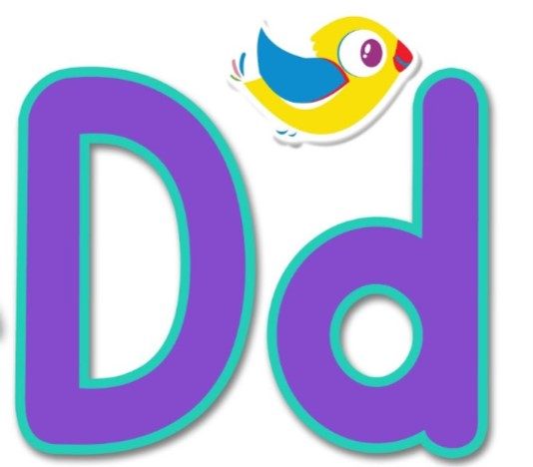

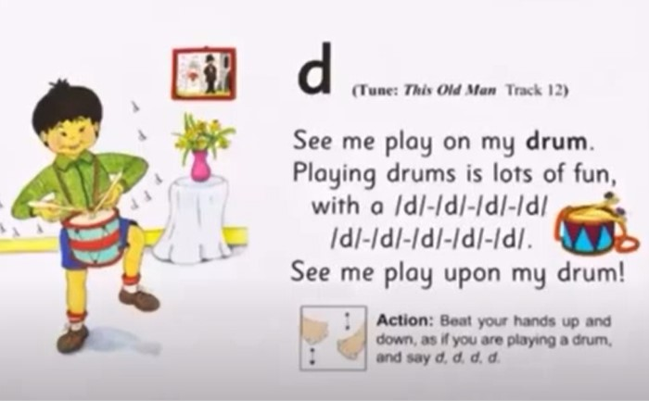
Duck begins with the ‘d’ sound.

Listen to the ‘d’ sound on Youtube:
https://www.youtube.com/watch?v=9_t8oCrN5pw
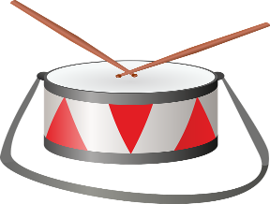
Can you think of anything else that begins with the ‘d’ sound?

