The Egyptians Challenge

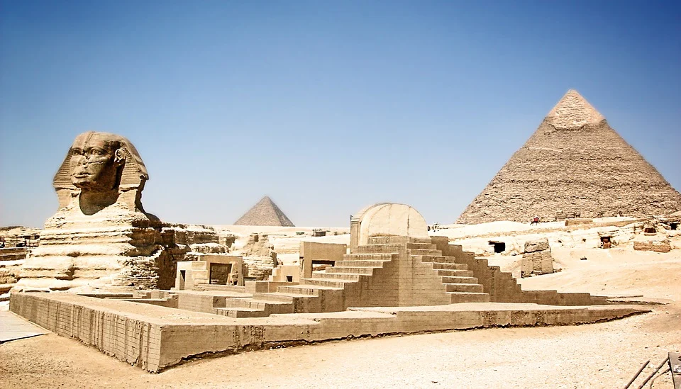

Many of you have completed many activities on our topic The Egyptians so why don’t you now challenge yourself?

- Many of you have created your own pyramids so think of an interesting way to explain the importance of these buildings. It could be a poster, a comic strip, instructions how to build a pyramid.

- Design your own canopic jar. Look at Egyptian art and create your own.

- Create a poster which shows everything you have learned about The Egyptians.

- Create a diary as if you were there and describe what life was like then.

- You may be more creative and think of another way to show how much you have learned.

When you have completed this challenge send it into school, take photos, video yourself and then we can share your work on Twitter.

Are you up for this challenge? We look forward to seeing your creations!

