Windy Arbor Primary School – Creative Curriculum Year 1  Spring Term | Topic: Moon Zoom
Key Question: What has happened in the past, what is happening and what will happen in outer space?
Summary
During this topic we will:
As historians we will explore key events in science and technology, as well as the famous moon landings.
As geographers we will explore different human and physical features of Earth and develop our knowledge of outer space, planets and moons.
As designers we will look at changes in art and we will create a moving parts project.
As musicians we will explore different types of music that fit into our topic.
As programmers we will explore and create coding programs.
Key Vocabulary
Earth | The planet on which we live.
Space | The area beyond Earth where the stars and planets are.
Moon | An object like a small planet that travels around a planet.
Planets | A large, round object in space.
Axle | A rod connecting a pair of wheels on a car or other vehicle.
Dowel | A short thin piece of wood which is used for joining larger pieces of wood together.
Pitch | How high or low a sound or piece of music is.
Dynamics | How loud or quiet a sound or piece of music is.
Program | To give a computer instructions to complete a task.
Code | To write a computer program.

Key People
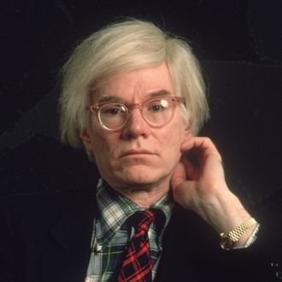
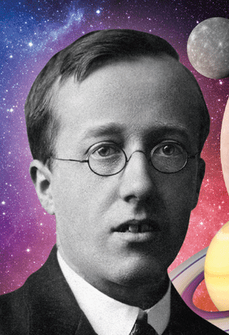
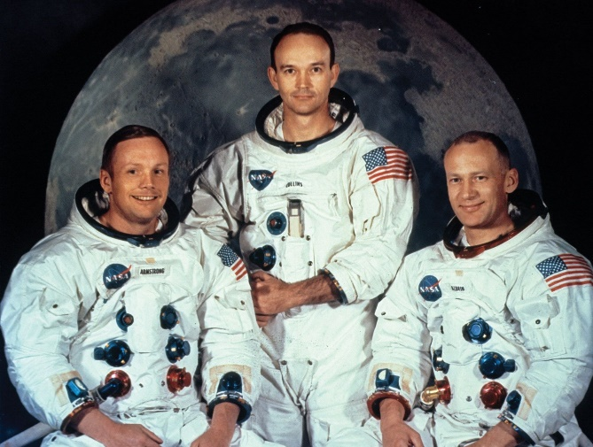
Gustav Holst
Andy Warhol
Neil Armstrong Buzz Aldrin

