Place Value
Base 10
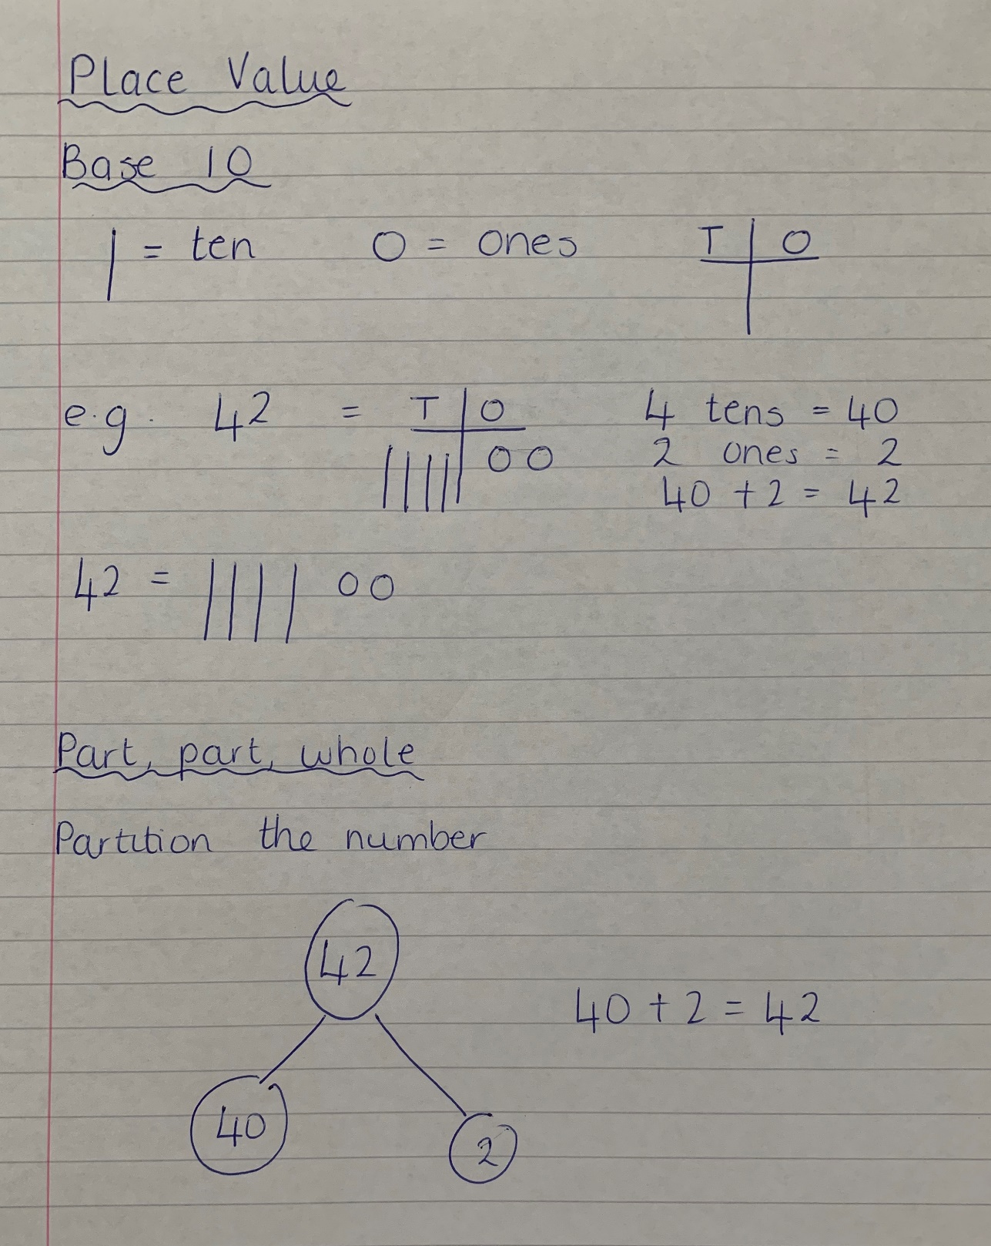
Part, part, whole
Partitioning the number

Addition 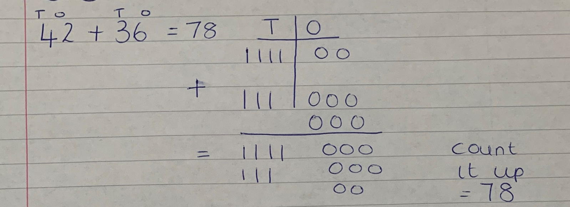
Subtraction
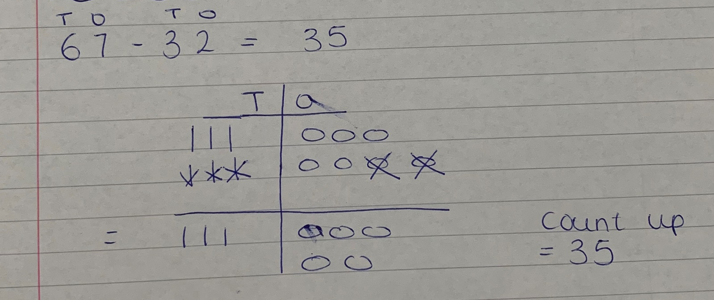

Multiplication – arrays
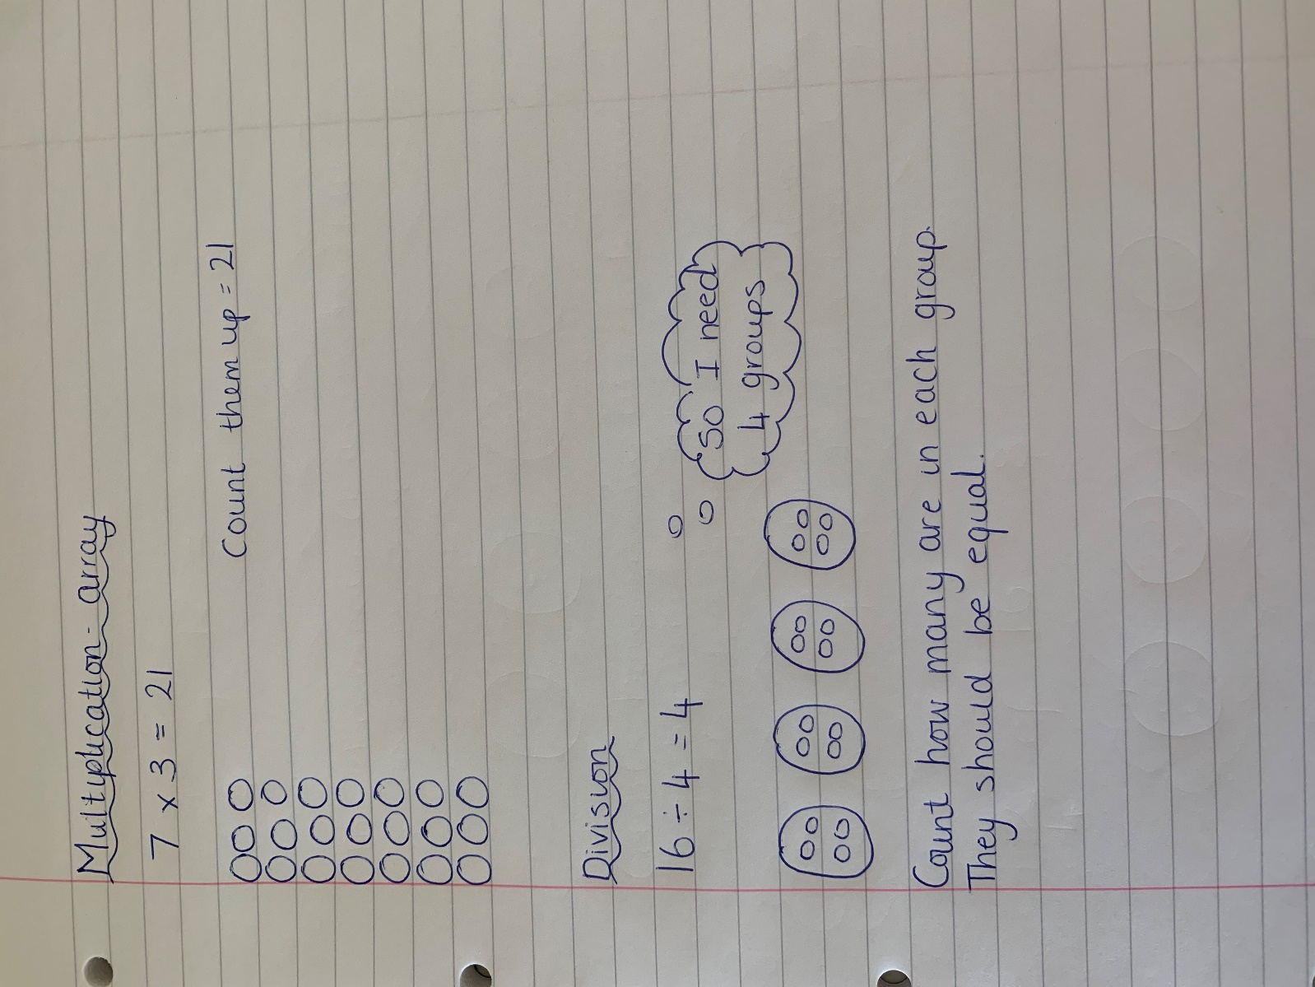

Division

Fractions
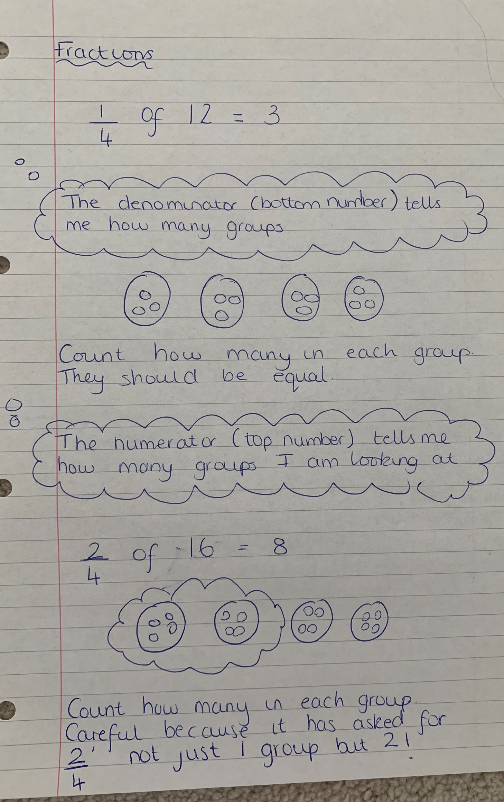

The denominator (bottom number) tells me how many groups I need.

Count how many are in each group. They should be equal.

The numerator (top number) tells me how many groups I am interested in.

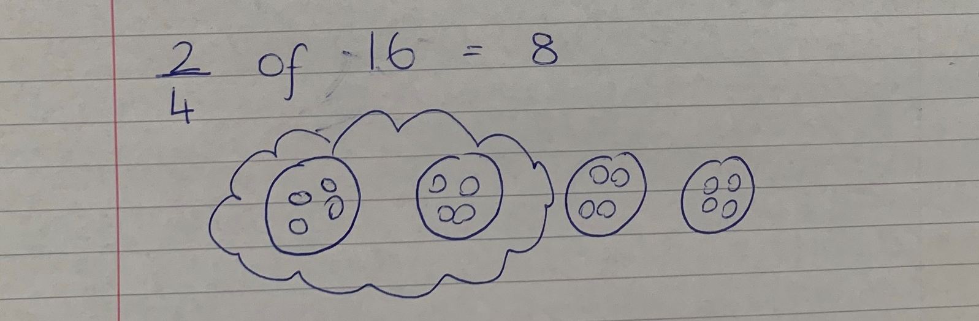
Count how many are in each group. They should be equal.
I need to be careful with this question because it asks about 2 groups not just 1.

