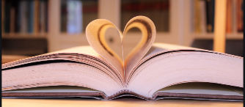
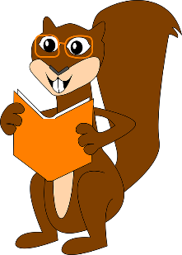
Here are some reading activities for you to complete at home. Remember these can be used for lots of different books. You can use books from school or home. Have fun. Mrs Braid and Miss Stevens
Summarise the main parts of the story into 3 sentences. | Find out the meaning to any words that you are unsure of and write them down. | Complete a book review about your book (on the website) | Make a list of all the adjectives you can find in your book. | Draw a picture of the setting.
Look at the front cover, what do you predict the story will be about? Are there any clues to help? | Write a diary entry pretending to be one of the characters from the book. | Summarise the story using pictures. | Create a new front cover and a blurb for the book. | Pick a part of the book. How do you think the character are feeling here? Why?
Draw the main characters and name them.  Draw a thought bubble to explain how they might be feeling or what they might be thinking. | Write and draw your favourite part of the book.  Why is this your favourite part? | Create 3 questions that you would like to ask a character from the book.  Remember your punctuation. | Make a list of all the nouns you can find in your book.  Do some of these have capital letters? Why? | Draw the character. On the outside write all the things you know about their appearance (what they look like).  On the inside, write everything you know about their personality. (E.g. they are kind or mean).
Make a list of all the verbs you can find in your book. | Retell the story using pictures. | What do you predict could happen to the characters next? | Does this book remind you of any other books? Why? | I see…  I think…  I wonder…

