  Science Year 2  K n o w l e d g e O r g a n i s e r |  | Topic:  Animals including Humans
 | National Curriculum Statements
- notice that animals, including humans, have offspring which grow into adults.
- find out about and describe the basic needs of animals, including humans, for survival (water, food and air).
- describe the importance for humans of exercise, eating the right amounts of different types of food, and hygiene.
Recall vocabulary
Growth – The process of increasing in size.
Nutrients – A substance that provides nourishment essential for the maintenance of life and for growth.
Consumption - The action of eating or drinking something.
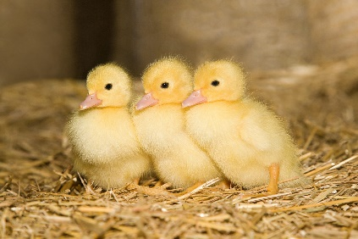

Key vocabulary
Adult – a fully grown animal or plant.
Offspring – the child of an animal.
Young – offspring which has not reached adulthood.
Life cycle - The life cycle of an animal or plant is the series of changes and developments that it passes through from the beginning of its life until its death.
Live young – offspring which has not hatched from an egg.
Reproduction – the process by which an animal or plant produces one or more individuals similar to itself.
Hygiene - the practice of keeping yourself and your surroundings clean.
Survival - managing to continue or exist in spite of difficult circumstances.
Temperature – how hot or cold something or someone is.
Exercise - When you exercise, you move your body energetically in order to get fit and to remain healthy

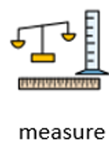
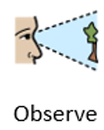
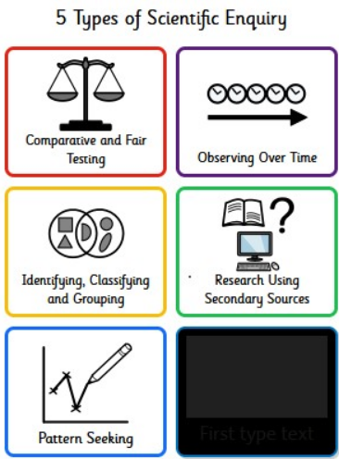
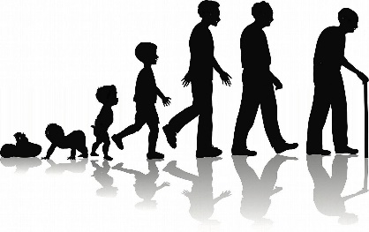
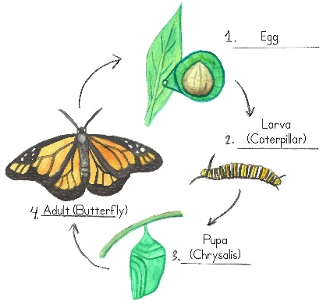

I am a scientist as I make discoveries and research how things work. I observe, measure, and talk about the results.
Key enquiry questions:
Which offspring belongs to which animal?
How is the lifecycle of an amphibian different to the lifecycle of a mammal?
What are the five basic needs of living things?
Which activity will make my heart rate faster?

