Windy Arbor Primary School Geography Year: 2 | 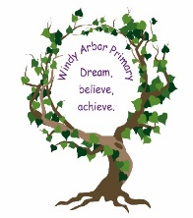  Topic: Comparing our  local area and Tulum, Mexico
Key question: What are the similarities and differences between my local area
and Tulum, Mexico?

Summary
In this unit, children will explore the world using atlases and globes. They will learn to identify the seven continents and five oceans, as well as the countries, capital cities and surrounding seas of the United Kingdom. Children will also discover the location and significance of the equator, the North Pole and the South Pole. Children will develop their fieldwork and map skills by creating simple maps of the school grounds and observing, recording and describing key features in the local area. They will study the human and physical geographical features of Tulum, Mexico and compare them to the features of their local area.

Key Vocabulary
Continent | any of the world's main continuous expanses of land
Equator | a line notionally drawn on the earth equidistant from the poles, dividing the earth into northern and southern hemispheres and constituting the parallel of latitude 0°
Scale | the relation between the real size of something and its size on a map, model, or diagram
Globe | a spherical representation of the earth or of the constellations with a map on the surface.
Location | a particular place or position
Atlas | a book of maps or charts
Locate | discover the exact place or position of
Capital City | the city or town that functions as the seat of government and administrative centre of a country or region
Country | an area of land with fixed borders that has full or limited control over its own government and laws.
Key questions – Overview (There are 3 overarching key learning questions, with sub-key questions within each).
- Can I use globes and atlases to
understand about the world?

- How can I represent the geographical features of my local area on a map?

- What are the similarities and differences between my local area and Tulum, Mexico?

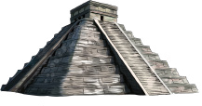
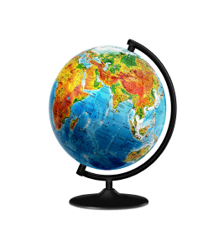
National Curriculum
- use world maps, atlases and globes to learn about the world’s seven continents and five oceans
- name, locate and identify characteristics of the four countries and capital cities of the United Kingdom and its surrounding seas
- understand geographical similarities and differences by studying their local area’s human and physical geography and Tulum, Mexico
- identify the hot and cold areas of the world, such as the equator and the North and South Poles
- use geographical vocabulary to refer to key physical and human features
- use simple compass directions and directional language
- use aerial photographs to recognise landmarks, devise simple maps and construct basic symbols using a key
- use simple fieldwork and observational skills to study the school’s geography and grounds



